- Suppose that N users are connected to a Router that uses1 Gpps link. Suppose that the users are active for 20% of time.
- How many users can use this network under circuit switching if a user requires 300 Mbps when the user is active?
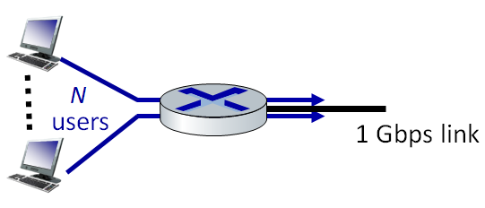
- Consider two hosts, A and B, connected by a single link of rate R =500kbps. Suppose that the two hosts are separated by 1000 km, and suppose the propagation speed along the link is 2.5*10⁸ meters/sec. Host A converts analog voice to a digital 64kpbs bit stream on the fly. Host A then groups the bits into 10Kb packets. Find the end-to-end delay. Consider the queuing delay as 0.5 msec.

- Consider the following Caravan analogy:
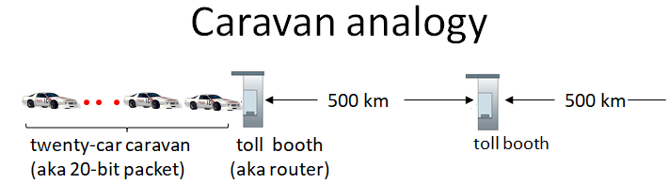
Suppose that the cars propagate at 2000 km/hr and toll booth takes two min to service a car. How many cars will remain at first booth if the first car arrives to 2nd booth?
- Suppose that the transmission rate at client link Rc = 2Mbps, at server link Rs = 10Mbps and backbone link R = 1Gbps. Find the throughput for the following scenario. Find the transmission time required to send 1Gbits data from a client to server.
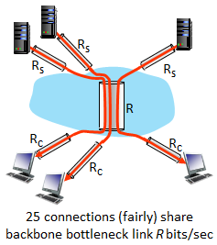
- Describe how the n-substitution cipher works with a figure.
- Describe packet sniffing with a figure.
- Describe how the FDM and TDM work with figures.
- Describe IP-spoofing with a figure.
- Describe digital signature with a figure. What are the differences between encryption and digital signature?

